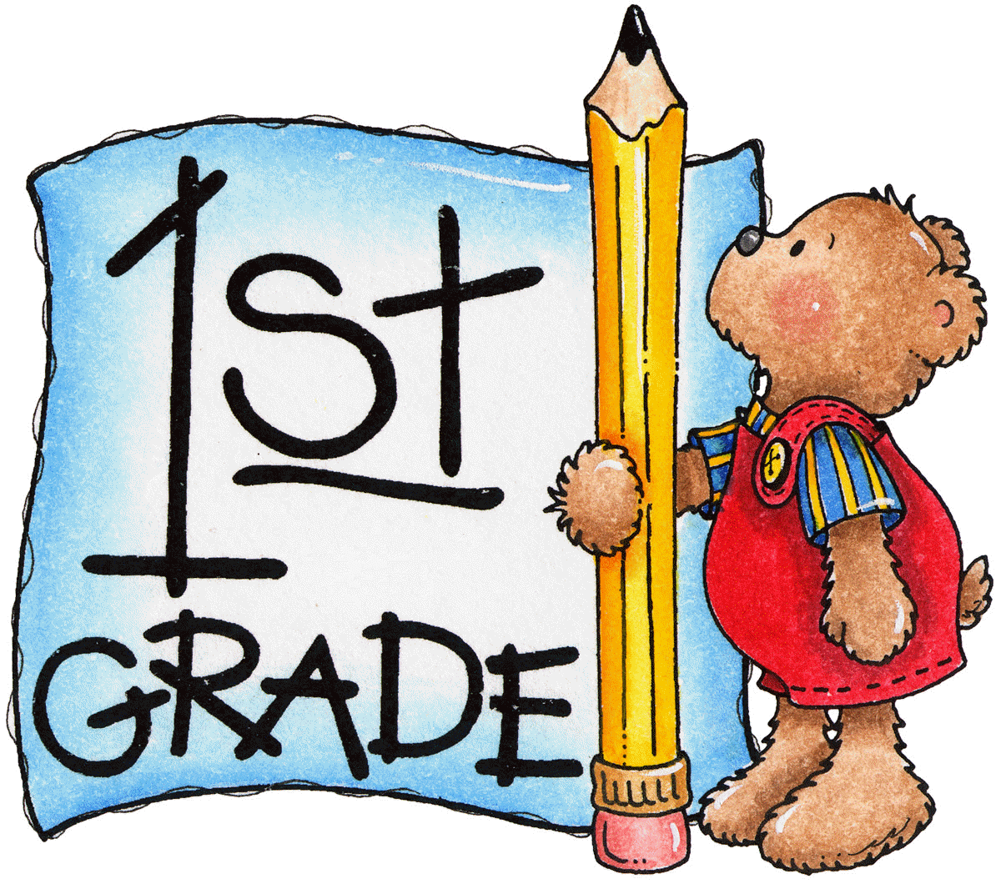

Mrs. Fernandes’ Supply List

2017-2018

**Bring to Meet & Greet!**

**PLEASE DO NOT label the supplies with your child’s name.**

* 24 pack of #2 **sharpened** pencils (Ticonderoga recommended)
* 1 box of colored pencils
* 1 box of Crayola Markers
* 2-Boxes of 24 count regular **Crayola** crayons
* 1 pack of Expo Dry Erase markers
* 1-Small (**snap close**) plastic pencil box (about 8 x 5.5)
* 6-**LARGE** glue sticks
* 1-Pair of **Fiskar** scissors
* 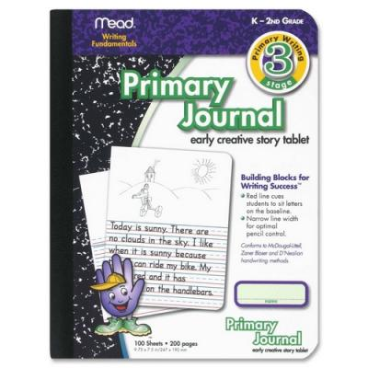 3-**PLASTIC pocket** folders **with prongs-1 Red,1 Green,1 Yellow**
* 1-Mead Primary Journal (see picture)
* 3-Mead wide ruled composition books (100 sheets)
* 1-RED plastic spiral notebook (70 sheets)
* 1-Box of regular sized tissues
* 1-one inch white binder with clear front sleave

|  |  |
| --- | --- |
| **GIRLS** | **BOYS** |
| * **Sandwich** sized Ziploc bags * 1-Container of hand sanitizer | * **Gallon** sized Ziploc bags * 1-Pack of Wet Ones hand wipes |